**CHAPTER 1**

**INTRODUCTION**

In today's challenging educational landscape, student success requires more than traditional methods. BRIGHTFUTURE is a comprehensive web application with **predictive analytics** and personalized support to tackle these challenges. It forecasts **dropout risks**, enables timely interventions, and provides **course recommendations** to guide students toward optimal pathways. By proactively identifying at-risk students and offering tailored guidance, BRIGHTFUTURE aims to boost engagement and improve academic outcomes.

BRIGHTFUTURE also includes a robust **note-taking application** for organised knowledge management and multimedia integration, promoting effective study habits. The platform's predictive and recommendation features foster student confidence and motivation. These combined functionalities make BRIGHTFUTURE essential for modern institutions, providing comprehensive support for student success and a brighter academic future.

**1.1 NEED FOR STUDY**

The escalating rates of student dropout and the increasing demand for personalized educational experiences highlight a critical gap in current academic support systems. Traditional methods often fail to identify at-risk students early enough, leading to preventable attrition and diminished educational outcomes. This study is essential to explore the efficacy of BRIGHT FUTURE, a web application designed to proactively address these challenges through predictive analytics and tailored course recommendations. By investigating the potential of this platform to identify and support students facing academic difficulties, this research aims to demonstrate the necessity for data-driven, personalized interventions in contemporary education.

Furthermore, the need for this study is underscored by the importance of holistic student support. Beyond predictive analytics, BRIGHTFUTURE integrates a robust note-taking system to enhance learning and organization. This research will investigate how the combined features of BRIGHTFUTURE contribute to improved student engagement, academic performance, and overall well-being. By examining the impact of a comprehensive, technology-driven approach, this study seeks to provide evidence for the adoption of innovative solutions that foster a more supportive and effective learning environment, ultimately ensuring a brighter academic future for all students.

**1.1.1 PROBLEM STATEMENT**

Educational institutions face a critical challenge with rising student dropout rates. Traditional support systems are often reactive, failing to address the root causes of attrition. This lack of proactive intervention leads to academic struggles, diminished confidence, and increased dropout likelihood. Moreover, students lack personalized academic guidance, resulting in misaligned course choices. The absence of integrated learning tools, like note-taking applications, further hinders effective knowledge management and study habits, contributing to academic difficulties.

Therefore, there's a pressing need for a comprehensive, data-driven platform. This platform should not only predict potential dropout risks but also provide personalized course recommendations and integrated learning tools. By fostering a more supportive and effective learning environment, such a platform would address the multifaceted problems contributing to student attrition and enhance overall academic success.

**1.2 OBJECTIVES**

The BRIGHTFUTURE aims to fulfil several key objectives to address the challenges identified in the problem statement.

**1.2.1 PRIMARY OBJECTIVE**

The primary objective of this project is to develop and evaluate a comprehensive web application, BRIGHTFUTURE, that utilizes predictive analytics and personalized recommendations to significantly reduce student dropout rates and enhance academic success within educational institutions. This will be achieved through the creation of a platform that proactively addresses the multifaceted challenges students face in their educational journey.

**1.2.2 SECONDARY OBJECTIVES**

Secondary objectives include the development of a robust predictive model capable of accurately identifying students at high risk of dropout, based on relevant academic and demographic data. Furthermore, we aim to design and implement a personalized course recommendation system that effectively aligns student interests and abilities with optimal academic pathways. An integrated note-taking application will also be created to facilitate organized knowledge management, multimedia resource storage, and effective study habits. We will evaluate the impact of BRIGHTFUTURE on student engagement, academic performance, and overall well-being through user testing and data analysis. Additionally, a user-friendly interface will be developed for easy adoption by students and educational staff. Finally, the project aims to provide educational institutions with a data-driven tool for proactive intervention and resource allocation and to investigate and document the effectiveness of combining predictive analytics with personalized support tools in an educational setting.

**1.3 SUMMARY**

BrightFuture addresses student dropout rates by using predictive analytics to identify at-risk students and provide timely interventions. It offers personalized course recommendations and an integrated note-taking application to improve student engagement and academic performance. This data-driven platform aims to create a supportive learning environment and reduce student attrition.

**CHAPTER 2**

**LITERATURE REVIEW**

**2.1 INTRODUCTION**

The persistent issue of student attrition across educational institutions underscores the critical need for innovative, data-driven interventions. Traditional support systems often struggle to address the complex and multifaceted factors contributing to dropout rates. In an era where personalized learning and proactive engagement are paramount, the development of intelligent systems capable of predicting student risk and providing tailored guidance is essential. This literature review explores the existing body of research on predictive analytics in education, course recommendation systems, and integrated learning platforms, examining the methodologies, successes, and limitations of prior studies. It aims to establish the context for the BrightFuture project, highlighting the necessity for a comprehensive solution that combines predictive modelling, personalised recommendations, and efficient knowledge management, including the ability to store multimedia files, to foster student success and mitigate academic attrition. This review will serve as a foundation for understanding the current landscape and justifying the development of BrightFuture as a significant contribution to the field of educational technology.

**2.2 REVIEW OF LITERATURE**

The BrightFuture system integrates three core components: a dropout prediction system, an online course recommendation system, and a note-taking application with database connectivity. This integration aims to provide a comprehensive solution for student success and retention in higher education.

Predicting student dropout is crucial for proactive intervention. Machine learning algorithms have demonstrated significant potential in this area. Research has explored applying ensemble methods and deep learning to enhance prediction accuracy. For instance, [1] showed that ensemble methods effectively predict student academic performance, a key indicator of dropout risk. Further demonstrated the efficacy of deep learning-based student performance prediction using multi-modal educational data. Moreover, the use of learning analytics dashboards enables instructors to monitor student engagement and identify at-risk students in real time [3]. The utilization of Natural Language Processing (NLP) to analyze student text data can also provide valuable information regarding student engagement and potential dropout [4].

Personalized course recommendations can significantly improve student engagement and academic success. Recommender systems in education leverage student data to suggest relevant courses. Machine learning algorithms, including collaborative filtering and content-based filtering, are commonly used for this purpose. Recent studies have investigated the use of hybrid recommendation systems that combine multiple algorithms to enhance accuracy [5]. Furthermore, the integration of intelligent tutoring systems and personalized learning pathways addresses the need for individualized support [5]. The ethical implications of using student data for personalized recommendations are also being explored [6].

A robust note-taking application with database connectivity is essential for efficient knowledge management and retrieval. Cloud-based note-taking applications offer accessibility and collaboration features. Research has examined the impact of mobile learning on student engagement [7], highlighting the importance of accessible note-taking tools. Database connectivity ensures data persistence and synchronization across devices. AI chatbots can provide student support within such an application [8]. Learning analytics to improve student well-being can also be incorporated into such a system [9].

The integration of these three components requires a robust system architecture and data management strategy. The use of cloud computing and microservices can facilitate scalability and maintainability. Furthermore, the development of a user-friendly interface is crucial for a seamless user experience. The ethical considerations of data privacy and security must be addressed throughout the system design process [6].

**2.3 REQUIREMENT ANALYSIS**

Requirement analysis for BrightFuture focuses on identifying the essential features needed to effectively support student success and mitigate dropout rates. The analysis involves integrating modules for predictive analytics, personalized course recommendations, and comprehensive note-taking capabilities. A well-defined requirement analysis ensures that the system supports smooth academic progression and enhances the overall educational experience for both students and educators.

**Functional Requirements**

* **Dropout Risk Prediction:** Implement predictive algorithms to forecast potential dropout risks based on internal marks, attendance, and tuition fee payment data.
* **Personalized Course Recommendations:** Develop a system to recommend courses based on student interests, skills, and current enrollment, providing direct links to course websites.
* **Integrated Note-Taking Application:** Create a platform for students to store notes and upload multimedia files (images, videos, PDFs), facilitating organized knowledge management.
* **Student Progress Tracking:** Provide a dashboard for students and educators to monitor academic progress, including internal marks and attendance.
* **Alert and Notification System:** Notify students and educators of potential dropout risks or course recommendation updates.
* **User Profile Management:** Allow students to manage their profiles, including skill and interest details, and view their academic history.

**Non-Functional Requirements**

* **Usability:** The interface must be user-friendly and intuitive, with easy navigation and access to key functionalities.
* **Performance:** The system should perform efficiently, even during peak usage, ensuring quick response times for predictions and recommendations.
* **Scalability:** The software should be scalable to accommodate increasing student data and the addition of new features, such as advanced analytics or personalized learning modules.
* **Security:** Ensure student data privacy and security through robust encryption and access control mechanisms.
* **Reliability:** The system should be reliable and available, minimizing downtime and ensuring consistent performance.

**2.3.1 SOFTWARE REQUIREMENTS SPECIFICATIONS**

**FRONT-END:**

1. **HTML (Hypertext Markup Language):** Used for structuring and formatting the content of the webpage, including:

• Creating the basic structure of the webpage (header, footer, navigation, etc.)

• Defining the layout of the input form

• Adding links to external stylesheets and scripts

1. **CSS (Cascading Style Sheets):** Used for styling and layout of the webpage, including:

• Defining the visual appearance of the webpage (colours, fonts, spacing, etc.)

• Creating responsive designs for different devices (desktop, tablet, mobile)

• Styling the registration form and its elements (input fields, buttons, etc.)

1. **JavaScript:** Used for creating interactive elements and dynamic effects on the webpage, including:

• Validating user input on the client side

• Creating dynamic effects (e.g., showing/hiding elements, animations)

• Handling events (e.g., form submission, button clicks)

1. **Bootstrap:** A front-end framework used for creating responsive and mobile-first designs, including:

• Providing a set of pre-built CSS classes for styling and layout

• Creating a responsive grid system for the layout

• Providing a set of pre-built components (e.g., navigation, alerts, modals)

**BACK-END:**

1. **DJANGO:** It is a high-level Python web framework that encourages rapid development and clean, pragmatic design.

* **Full-Stack Web Development:** Django is designed for building comprehensive, database-driven web applications. Its "batteries-included" philosophy provides developers with built-in features for handling everything from database management to user authentication, enabling the creation of complex applications with less code.
* **Rapid Development and Scalability:** Django's robust architecture and reusable components facilitate rapid development, allowing developers to quickly build and deploy web applications. Its design also supports scalability, making it suitable for handling high traffic and growing user bases.
* **Security and Maintainability:** Django prioritizes security, providing built-in protection against common web vulnerabilities like SQL injection and cross-site scripting. Its well-structured design and adherence to the DRY (Don't Repeat Yourself) principle promote maintainable code, making it easier to update and extend applications over time.

1. **PYTHON:** Python is a widely popular, easy-to-learn programming language that empowers developers to create a diverse range of applications.

* **Building Web Applications:** Python provides robust frameworks like Django and Flask, which enable the creation of dynamic and efficient web applications, from simple websites to complex web services.
* **Data Science and Visualization:** Python's extensive ecosystem of libraries, including Pandas, NumPy, and Matplotlib, makes it a leading choice for data analysis, manipulation, and visualization, allowing users to extract meaningful insights from data.
* **General-Purpose Software Development:** With its vast collection of libraries and frameworks, Python is used to develop a broad spectrum of software, including desktop applications, games, and sophisticated backend systems, offering developers flexibility and efficiency.

1. **POSTGRESQL:** PostgreSQL is a powerful, open-source object-relational database management system (ORDBMS) known for its reliability, feature robustness, and SQL compliance.

* **Web Application Backend:** PostgreSQL is widely used as a robust database backend for web applications, often in conjunction with frameworks like Django, providing advanced data management capabilities.
* **Data Integrity and Extensibility:** PostgreSQL emphasizes data integrity with features like ACID compliance and offers extensive extensibility through stored procedures, user-defined functions, and a wide range of extensions, ensuring data reliability and flexibility.
* **Data Warehousing and Analytics:** PostgreSQL's advanced query capabilities and support for complex data types make it suitable for data warehousing and analytical workloads, enabling efficient data analysis and reporting.

1. **AWS S3 (Amazon Simple Storage Service):** AWS S3 is an object storage service offering scalability, data availability, security, and performance.

* **Media Storage and Distribution:** S3 is used to store and distribute media files, such as images, videos, and audio, supporting streaming and on-demand content delivery.
* **Application Data Storage:** S3 stores application data, including user-generated content, configuration files, and log files, providing a scalable and accessible storage layer for various applications.
* **Data Backup and Archiving:** S3 provides a durable and reliable storage solution for backing up and archiving critical data, enabling data recovery and long-term data retention.

**2.4 PROPOSED MODEL**

The BrightFuture system aims to create a dynamic and supportive educational ecosystem through a web-based platform that empowers students and institutions alike. By integrating predictive analytics, personalized recommendations, and comprehensive learning tools, BrightFuture provides a proactive approach to student success. Students gain access to tailored guidance, while institutions gain valuable insights into student progress and potential challenges. The system facilitates seamless knowledge management through a versatile note-taking application and provides actionable recommendations based on individual student data. This creates a collaborative environment where students are equipped to achieve their academic goals, and institutions are enabled to provide effective support.

**Key Features:**

* **Proactive Student Support:** The system delivers real-time predictive analysis of student dropout risks, allowing for early intervention and personalized support strategies. This ensures that students receive timely assistance, preventing academic setbacks and enhancing overall success.
* **Tailored Academic Guidance:** Students receive personalized course recommendations that align with their interests, skills, and academic performance, enabling them to make informed decisions about their educational pathways. This personalized approach fosters engagement and promotes academic achievement.
* **Integrated Learning Environment:** The platform provides a robust note-taking application with multimedia capabilities, allowing students to organize and access their learning materials efficiently. This integrated environment supports diverse learning styles and promotes effective knowledge management.
* **Data-Driven Institutional Insights:** Educational institutions gain access to comprehensive data and analytics, providing valuable insights into student progress and potential challenges. This data-driven approach enables institutions to optimize resource allocation and implement effective support strategies.
* **Enhanced Student Engagement:** Through personalized recommendations and proactive support, students are actively engaged in their learning journey. The system promotes a sense of ownership and empowerment, leading to increased motivation and academic success.

**SUMMARY**

It gives an overview of BrightFuture, an educational support system designed to address key challenges faced by students and educational institutions. It highlights the importance of proactive student support in the context of increasing academic pressures and the need for personalized, data-driven solutions. It examines the current state of educational support systems, pointing out limitations such as the lack of predictive analytics, personalized course recommendations, and integrated knowledge management tools. Finally, the proposed model details the advantages of BrightFuture, including early identification of at-risk students, tailored academic guidance, improved knowledge retention through multimedia note-taking, and data-driven institutional insights. These features are designed to create a more supportive, efficient, and successful learning environment.

**CHAPTER 3**

**DESIGN SPECIFICATION**

**3.1 TABLE DESIGN**

Table design involves organizing data into structured tables within a database. It ensures that data is stored efficiently, relationships between data elements are clear, and retrieval and manipulation are straightforward.

A table is a collection of related data organized in rows and columns. Each table represents an entity or a concept. Tables consist of columns (fields) and rows (records). Each column holds a specific type of data, and each row represents a unique record.

The following are the tables that are involved in the proposed application:

1. Table Name: auth_group

Primary Key: id

| **ATTRIBUTE** | **FIELD_TYPE** | **DESCRIPTION** |
| --- | --- | --- |
| id | integer | The ID of the user |
| name | character varying(150) | Name of the user |

1. Table Name: auth_group_permissions

Primary Key: id

Foreign Key: group_id

permission_id

| **ATTRIBUTE** | **FIELD_TYPE** | **DESCRIPTION** |
| --- | --- | --- |
| id | bigint | Unique identifier for each record. |
| group_id | integer | Links to a group in auth_group |
| permission_id | integer | Links to a permission in auth_permission. |

1. Table Name: auth_permission

Primary Key: id

Foreign Key: content_type_id

| **ATTRIBUTE** | **FIELD_TYPE** | **DESCRIPTION** |
| --- | --- | --- |
| id | integer | Unique permission identifier. |
| name | character varying(255) | Human-readable permission name. |
| content_type_id | integer | Links to the content type the permission applies to. |
| codename | character varying(100) | Machine-readable permission code. |

1. Table Name: auth_user

Primary Key: id

| **ATTRIBUTE** | **FIELD_TYPE** | **DESCRIPTION** |
| --- | --- | --- |
| id | integer | Unique user identifier. |
| password | character varying(128) | User's encrypted password. |
| last_login | timestamp with time zone | Timestamp of the user's last login. |
| is_superuser | boolean | Indicates if the user has superuser privileges. |
| username | character varying(150) | User's login username. |
| first_name | character varying(150) | User's first name. |
| last_name | character varying(150) | User's last name. |
| email | character varying(254) | User's email address. |
| is_staff | boolean | Indicates if the user has staff privileges. |
| is_active | boolean | Indicates if the user account is active. |
| date_joined | timestamp with time zone | Timestamp of when the user account was created. |

1. Table Name: auth_user_groups

Primary Key: id

Foreign Key: user_id

group_id

| **ATTRIBUTE** | **FIELD_TYPE** | **DESCRIPTION** |
| --- | --- | --- |
| id | bigint | Unique record identifier. |
| user_id | integer | Links to a user in auth_user. |
| group_id | integer | Links to a group in auth_group. |

1. Table Name: auth_user_user_permissions

Primary Key: id

Foreign Key: user_id

permission_id

| **ATTRIBUTE** | **FIELD_TYPE** | **DESCRIPTION** |
| --- | --- | --- |
| id | bigint | Unique record identifier. |
| user_id | integer | Links to a user in auth_user. |
| permission_id | integer | Links to a permission in auth_permission. |

1. Table Name: django_admin_log

Primary Key: id

Foreign Key: content_type_id

user_id

| **ATTRIBUTE** | **FIELD_TYPE** | **DESCRIPTION** |
| --- | --- | --- |
| id | integer | Unique log entry identifier. |
| action_time | timestamp with time zone | Timestamp of the action. |
| object_id | text | Identifier of the affected object. |
| object_repr | character varying(200) | String representation of the affected object. |
| action_flag | smallint | Type of action performed. |
| change_message | text | Description of the change. |
| content_type_id | integer | Links to the type of object affected. |
| user_id | integer | Links to the user who performed the action. |

1. Table Name: django_content_type

Primary Key: id

| **ATTRIBUTE** | **FIELD_TYPE** | **DESCRIPTION** |
| --- | --- | --- |
| id | integer | Unique content type identifier. |
| app_label | character varying(100) | The name of the Django application. |
| model | character varying(100) | The name of the Django model. |

1. Table Name: django_migrations

Primary Key: id

| **ATTRIBUTE** | **FIELD_TYPE** | **DESCRIPTION** |
| --- | --- | --- |
| id | bigint | Unique migration record identifier. |
| app | character varying(255) | The name of the Django app the migration belongs to. |
| name | character varying(255) | The name of the migration. |
| applied | timestamp with time zone | Timestamp of when the migration was applied. |

1. Table Name: django_session

Primary Key: session_key

| **ATTRIBUTE** | **FIELD_TYPE** | **DESCRIPTION** |
| --- | --- | --- |
| session_key | character varying(40) | Unique identifier for the session. |
| session_data | text | Serialized data associated with the session. |
| expire_date | timestamp with time zone | Timestamp when the session expires. |

1. Table Name: main_app_collection

Primary Key: id

Foreign Key: user_id

| **ATTRIBUTE** | **FIELD_TYPE** | **DESCRIPTION** |
| --- | --- | --- |
| id | bigint | Unique collection identifier. |
| name | character varying(100) | Name of the collection. |
| description | text | Description of the collection. |
| date_created | timestamp with time zone | Timestamp when the collection was created. |
| date_updated | timestamp with time zone | Timestamp when the collection was last updated. |
| shared | boolean | Indicates if the collection is shared. |
| user_id | integer | Links to the user who owns the collection. |

1. Table Name: main_app_collection_notes

Primary Key: id

Foreign Key: collection_id

note_id

| **ATTRIBUTE** | **FIELD_TYPE** | **DESCRIPTION** |
| --- | --- | --- |
| id | bigint | Unique record identifier. |
| collection_id | bigint | Links to a collection in main_app_collection. |
| note_id | bigint | Links to a note in main_app_note. |

1. Table Name: main_app_collection_references

Primary Key: id

Foreign Key: collection_id

reference_id

| **ATTRIBUTE** | **FIELD_TYPE** | **DESCRIPTION** |
| --- | --- | --- |
| id | bigint | Unique record identifier. |
| collection_id | bigint | Links to a collection in main_app_collection. |
| reference_id | bigint | Links to a reference in main_app_reference. |

1. Table Name: main_app_note

Primary Key: id

| **ATTRIBUTE** | **FIELD_TYPE** | **DESCRIPTION** |
| --- | --- | --- |
| id | bigint | Unique note identifier. |
| content | text | The content of the note. |

1. Table Name: main_app_profile

Primary Key: id

Foreign Key: user_id

| **ATTRIBUTE** | **FIELD_TYPE** | **DESCRIPTION** |
| --- | --- | --- |
| id | bigint | Unique profile identifier. |
| user_id | integer | Links to the user associated with the profile. |

1. Table Name: main_app_profile_collections_saved

Primary Key: id

Foreign Key: profile_id

collection_id

| **ATTRIBUTE** | **FIELD_TYPE** | **DESCRIPTION** |
| --- | --- | --- |
| id | bigint | Unique record identifier. |
| profile_id | bigint | Links to a profile in main_app_profile. |
| collection_id | bigint | Links to a collection in main_app_collection. |

1. Table Name: main_app_reference

Primary Key: id

Foreign Key: user_id

| **ATTRIBUTE** | **FIELD_TYPE** | **DESCRIPTION** |
| --- | --- | --- |
| id | bigint | Unique reference identifier. |
| name | character varying(100) | Name of the reference. |
| type | character varying(1) | Type of reference (e.g., 'B' for book, 'A' for article). |
| url | character varying(100) | URL of the reference |
| user_id | integer | Links to the user who created the reference. |

**3.2 DATA FLOW DIAGRAM**

**LEVEL 0**

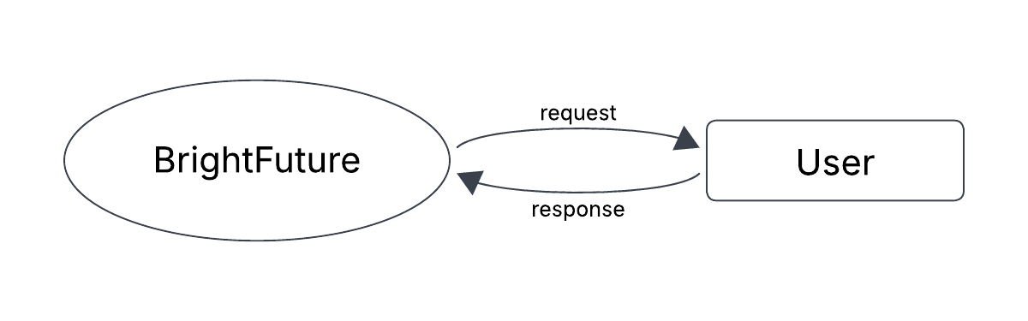Fig 3.2.1 DFD LEVEL 0 (Note-Taking App)

**LEVEL 1**

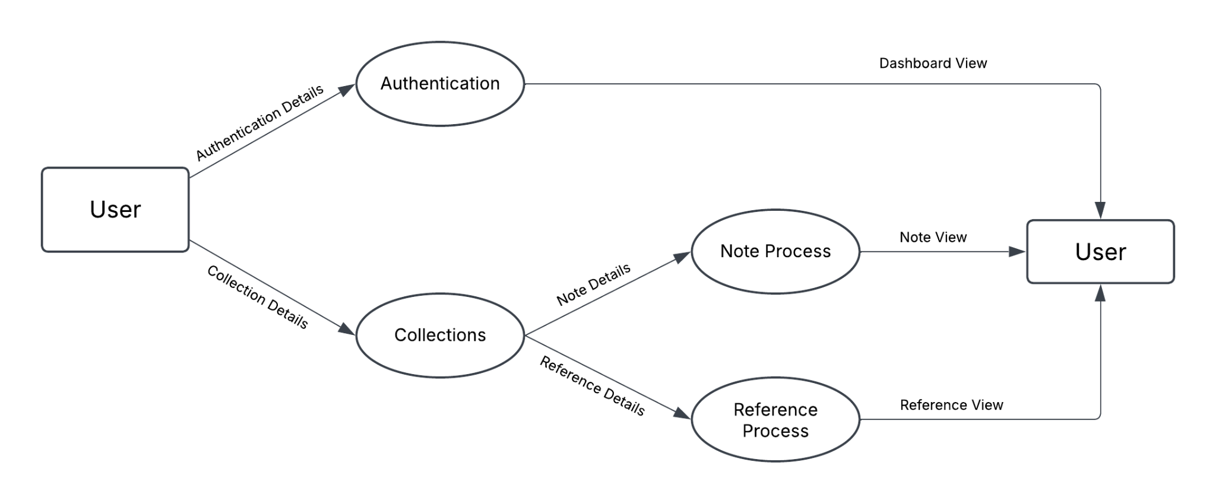

Fig 3.2.2 DFD LEVEL 1 (Note-Taking App)

**LEVEL 2**

LEVEL 2.1 REGISTRATION

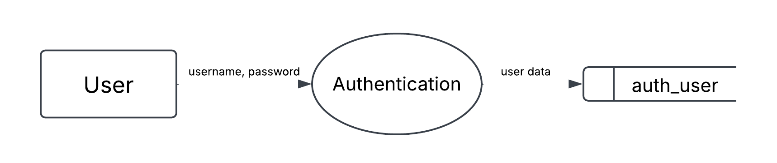

Fig 3.2.2 DFD LEVEL 2.1 ( Registration Process )

LEVEL 2.2 CREATION

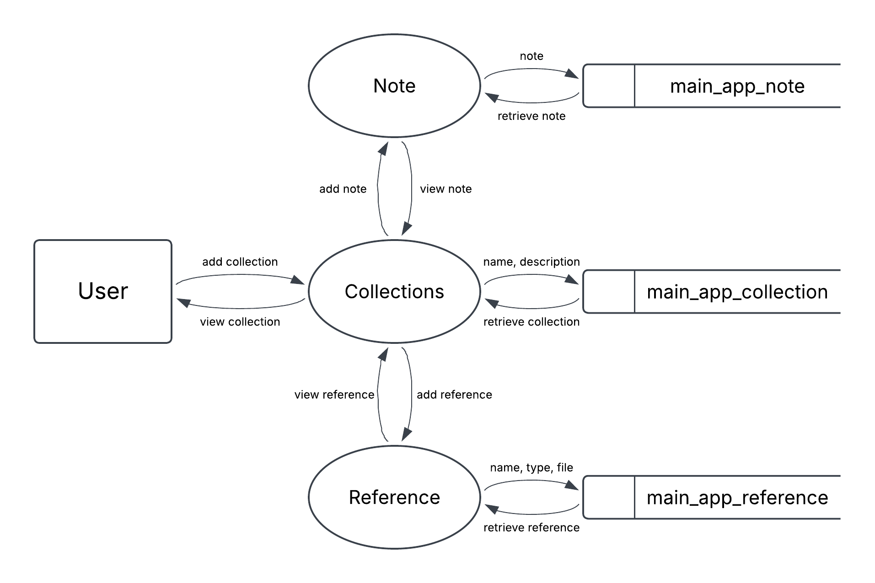

Fig 3.2.4 DFD LEVEL 2.2 ( Creation Process )

LEVEL 2.3 EDITING

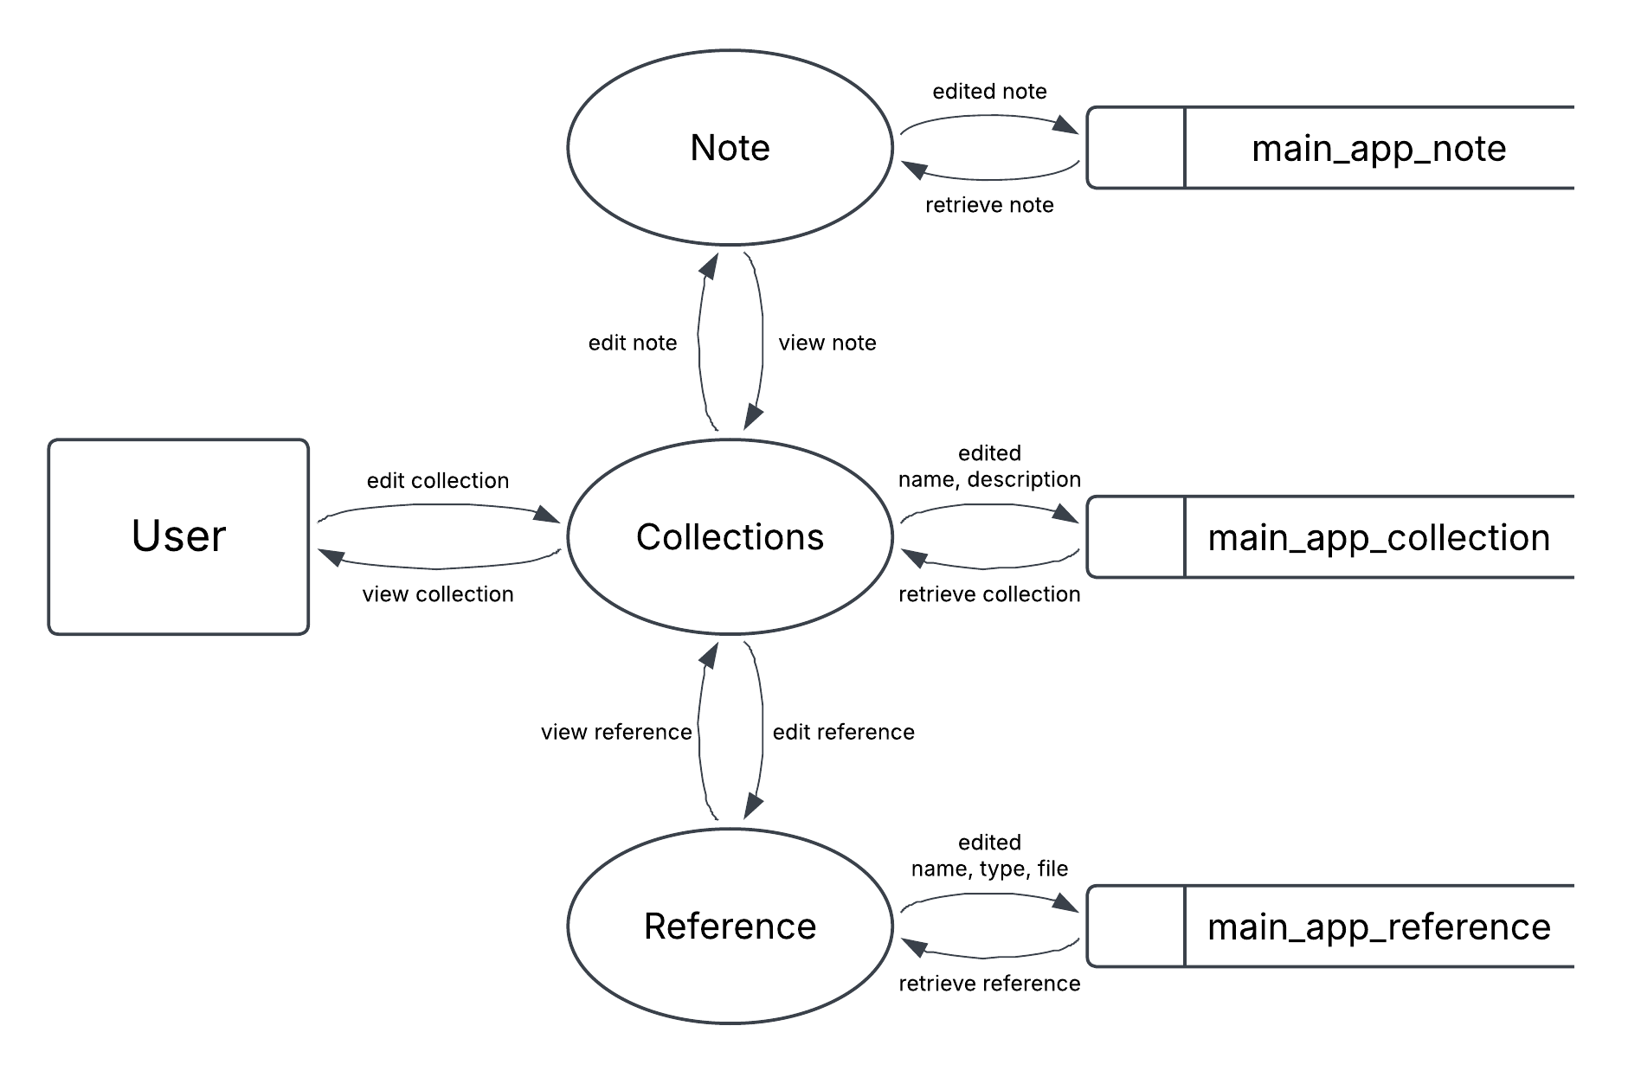

Fig 3.2.5 DFD LEVEL 2.3 ( Editing Process )

LEVEL 2.3 DELETION

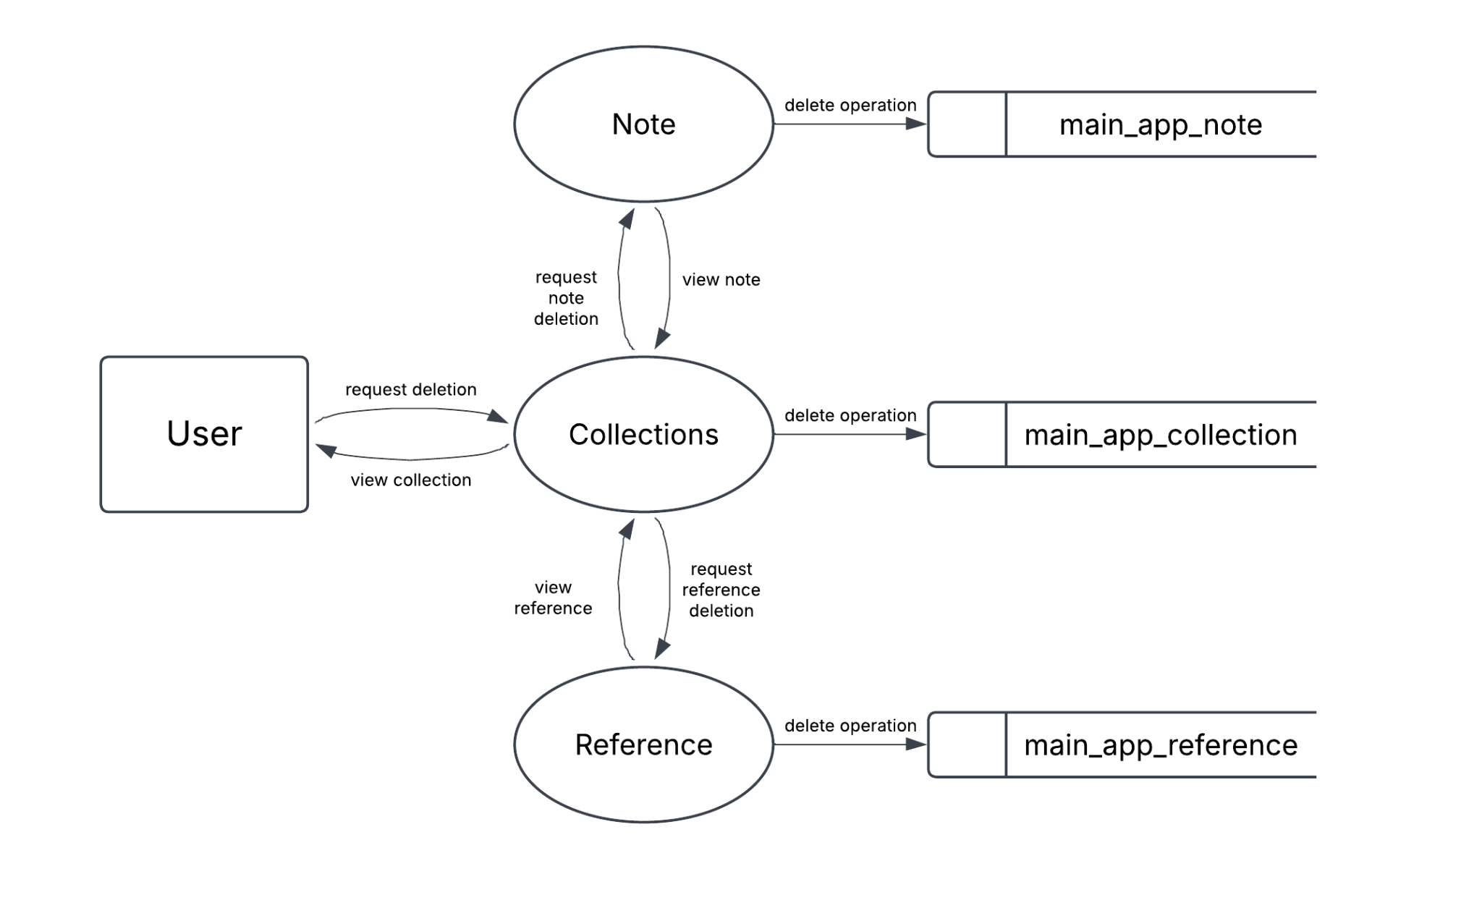

Fig 3.2.6 DFD LEVEL 2.3 ( Deletion Process )

**3.3 WORKFLOW ( ML MODEL )**

**REFERENCES**

[1] A. Hussain, S. Zhu, W. Zhang, and S. Abedin, "Predicting Student Academic Performance Using Ensemble Methods," *IEEE Access*, vol. 7, pp. 135245-135256, 2019.

[2] Y. Kim, H. Lee, and J. Park, "Deep Learning-Based Student Performance Prediction Using Multi-Modal Educational Data," in *2020 International Conference on Information and Communication Technology Convergence (ICTC)*, Jeju Island, Korea (South), 2020, pp. 156-159.

[3] M. Khalil, M. Ebner, and M. Kopp, "Learning Analytics Dashboards: A Systematic Review," in *2018 IEEE Global Engineering Education Conference (EDUCON)*, Santa Cruz de Tenerife, Spain, 2018, pp. 1095-1102.

[4] S. Crossley, D. S. McNamara, and P. Allen, "Using natural language processing to predict student engagement from online forum posts," *IEEE Transactions on Learning Technologies*, vol. 12, no. 1, pp. 88-100, 2019.

[5] R. Nkambou, J. Bouchard, and G. Psaromiligkos, "Intelligent Tutoring Systems: A Survey and Roadmap," *Information and Software Technology*, vol. 115, pp. 66-82, 2019.

[6] G. Holmes, "Ethical considerations in the use of learning analytics in higher education," *Educational Technology Research and Development*, vol. 68, no. 5, pp. 1957-1979, 2020.

[7] A. Kukulska-Hulme, U. Cress, and A. B. Chhokar, "Mobile learning for quality education and social inclusion," *Distance Education*, vol. 37, no. 2, pp. 244-259, 2016.

[8] R. Fryer, B. Ainley, and J. Thompson, "Chatbots in education: a review of the literature," in *EdMedia + Innovate Learning*, 2019, pp. 780-788.

[9] M. Ifenthaler, D. Shum, and X. Y. Yau, *Learning analytics: From research to practice*, Routledge, 2016.